- Monthly Meeting  STARTING  May 13, 2021  7:00 PM – 8:00PM | NIA 20 PRESENTS  GRAPEVINE WORKSHOP
Topic:  How Steps Changed my Life  Topic: NIA 20 Grapevine Workshop (2nd Thursday of every month)  Time: Feb 11, 2021 07:00 PM Central Time (US and Canada)  Every month on the Second Thu, until Dec 9, 2021, 11 occurrence(s)  Feb 11, 2021 07:00 PM  Mar 11, 2021 07:00 PM  Apr 8, 2021 07:00 PM  May 13, 2021 07:00 PM  Jun 10, 2021 07:00 PM  Jul 8, 2021 07:00 PM  Aug 12, 2021 07:00 PM  Sep 9, 2021 07:00 PM  Oct 14, 2021 07:00 PM  Nov 11, 2021 07:00 PM  Dec 9, 2021 07:00 PM  Join Zoom Meeting  Meeting ID: 838 5328 2292  Passcode: grapevine  Email questions to:  gpv@aa-nia-dist40.org  AA D40 web page:  www.aa-nia-dist40.org  Reach an Alcoholic:  630-653-6556 | WHATS UP WITH GRAPEVINE”  What is Grapevine  Come join us, learn Grapevine history, What’s new in GV, How to access GV  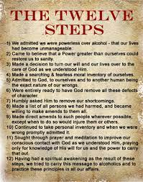  NEW TOPICS EVERY MONTH  May Topic “How the Steps Changed My Life”  Please join this interactive workshop where we will show you the How To’s of Grapevine and what benefits are available to you and your program.

